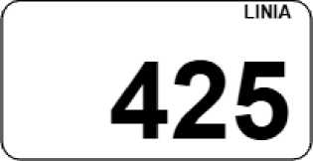
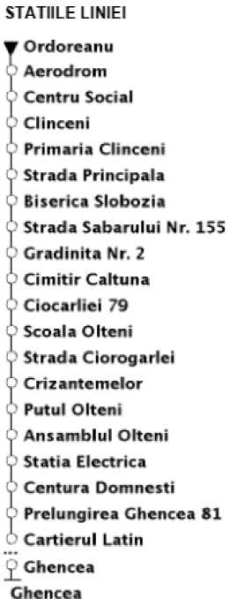

natale Gin prograrnu da dreutafie au caracter oriantady. Respectarea programului da circuade dEpinda de cordidile de trafic de pa trasau
PROGRAMUL TRECERILOR PRIN STATIE

ORDOREANU
Ordoreanu - Ghencea
^entru a afla in dmp real orala da sosire ir Etadi a vaflicuiaior, STB SA recomanda uliizarea aplicai^ gratuite infa TrarEpurt Bucure&U

Luni - Vineri |  |  |  |  | Sambata - Duminica
Cap linie ORDOREANU |  | Cap linie CASA DE CULTURA CLINCENU |  |  | Cap linie ORDOREANU |  | Cap linie CASA DE CULTURA CLINCENU
Ora | Minutul |  | Ora | Minutul | Ora | Minutul | Ora | minutul
05 | 30 |  | 05 | 00...55 | 05 | 50 | 05 | 00
06 | 25 |  | --- | --------- | 6 | -50 | --- | ------
07 | 05 |  | 07 | 50 | ---------- | --------------------- | 07 | 00
08 | 30 |  | ---- | ------------- | 08 | 05 | ---- | ---------
09 | 40 |  | 09 | 05 | ------ | ------------- | 09 | 15
10 | 50 |  | 10 | 15 | 10 | 20 | ------ | -------
----- | ------------- |  | 11 | 25 | ----- | ------- | 11 | 20
12 | 00 |  | 12 | 30 | 12 | 30 | ------ | ----------
13 | 00 |  | 13 | 35 | ---- | ---------------- | 13 | 00
14 | 10 |  | 14 | 55 | 14 | 30 | ---- | -------
15 | 35 |  | ------ | ----------- | ---- | ----- | 15 | 00
16 | 50 |  | 16 | 15 | 16 | 30 | ------ | -----------
--- | ------ |  | 17 | 30 | -- | ------- | 17 | 45
18 | 05 |  | 18 | 40 | 18 | 50 | ------ | -----------
19 | 50 |  | 19 | 15 | ------ | ------- | 19 | 55
--- | ------ |  | 20 | 25 | 2.0 | 55 | ----- | --------------
21 | 20 |  | 21 | 55 | ----- | ----- | 21 | 00
22 | 35 |  | ---- | -------- | --- | --------- | 22 | 00

